Outline

**Outline**

***Ogo***

-> take pic of a list of components

4wd acrylic build

(online resources - pics & vids) ((a lot

<https://youtu.be/5j_mL10tYmQ?si=va8B-R_V3IdbvNx_>

Circuitry - rebuild it in canva (i could help on this)

<https://www.canva.com/design/DAG4-lZN0mc/OnkHaOHqFe1y5180GFyX3w/edit?utm_content=DAG4-lZN0mc&utm_campaign=designshare&utm_medium=link2&utm_source=sharebutton>

What is motor driver

***Sagili***

Esp32

What is it

Basics - Pins

Set up steps

Buck converter

<https://shopee.com.my/DC-DC-Step-Down-USB-5V-3A-Voltage-Regulator-Module-Buck-Converter-i.126211897.3277421553?extraParams=%7B%22display_model_id%22%3A63476753933%2C%22model_selection_logic%22%3A3%7D&sp_atk=9e314a1d-bc17-47e2-95de-188672a49a7f&xptdk=9e314a1d-bc17-47e2-95de-188672a49a7f>

(just go through theory part cuz only using this; and this is fixed so no need to adjust)

Servos

Go with one servo calibration will do

Prep the materials for tmr dry run (~2 teams)

-> build another pcb *(how’s the prev pcb)*

-> 3 robot car from dr richard; 1 from seru

-> borrow breadboard

Car Base

**INTRODUCTION**

Today we are assembling a 4-wheel robot base. You will learn:

1. How the L298N motor driver works

2. How to wire four DC motors

3. What each pin on the motor driver does

4. How to mount the electronics using female–female standoffs

5. How to connect the motor driver to the ESP32

1.0 Car Base Building

1.1 List of Components for Car Base

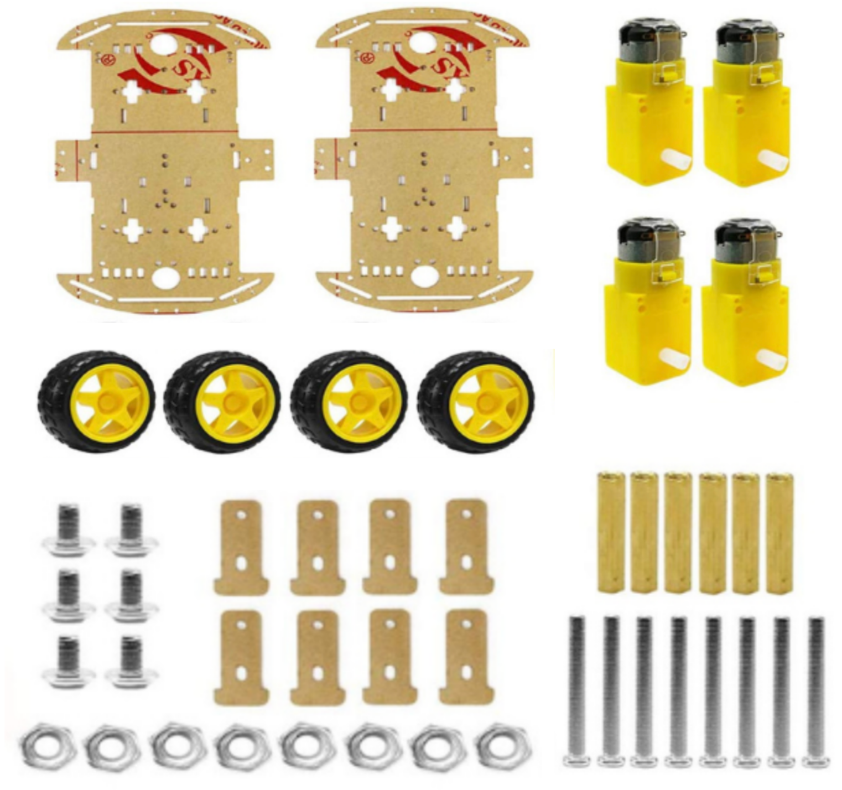

*2 x chassis*

*4 x wheel*

*4 x TT Motor*

*8 x M3*30 Screw*

*8 x Fastener*

*6 x M3*8 Screw*

*8 x M3 Nut*

*6 x L30+6 F-F Standoffs*

1.2 Steps of Assembly

| *Step 1: Insert the fasteners and Install the code wheels and fix the motors to the chassis. (Attention: The copper sheets of the leading wires of the motors should face outward, on the same side as the wheels AND the head of the screws(blunt part) should point outwards.* | *Step 2: After fixing the motors to the chassis, insert and tighten the screws.* |
| --- | --- |
| *Step 3: Hold the chassis tightly and insert the wheels to the motors.* | *Step 4: Insert the spacers, tighten them with screws from the bottom and then with screws from the upper side. Installation is then completed.* |
| *Completed installation.* |  |

1.3 Mounting With Standoffs



Figure 1.3

Purpose of the standoffs:

· Lifts the electronics platform

· Provides space for motor wires and battery

· Makes the robot look neat and stable

### How to Install

1. Insert four screws at each corner of the chassis from the bottom of the chassis into the standoff.

2. The standoff becomes a vertical pillar.

3. Place the electronics plate (top deck) on the standoffs.

4. Secure with screws from the top.

5. Mount the ESP32 onto the elevated platform.

1.3 L298N Motor-Driver

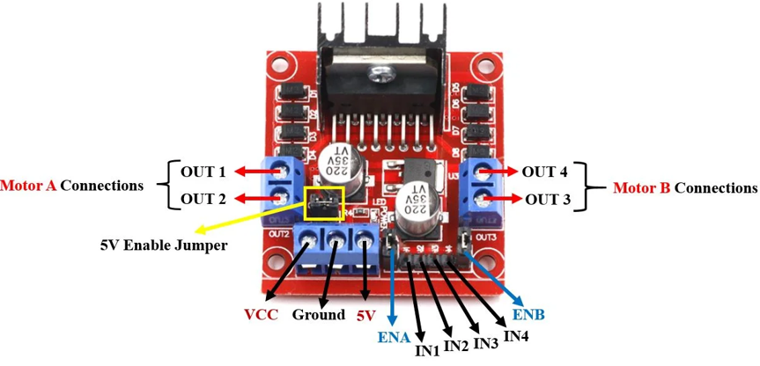

Figure 1.1

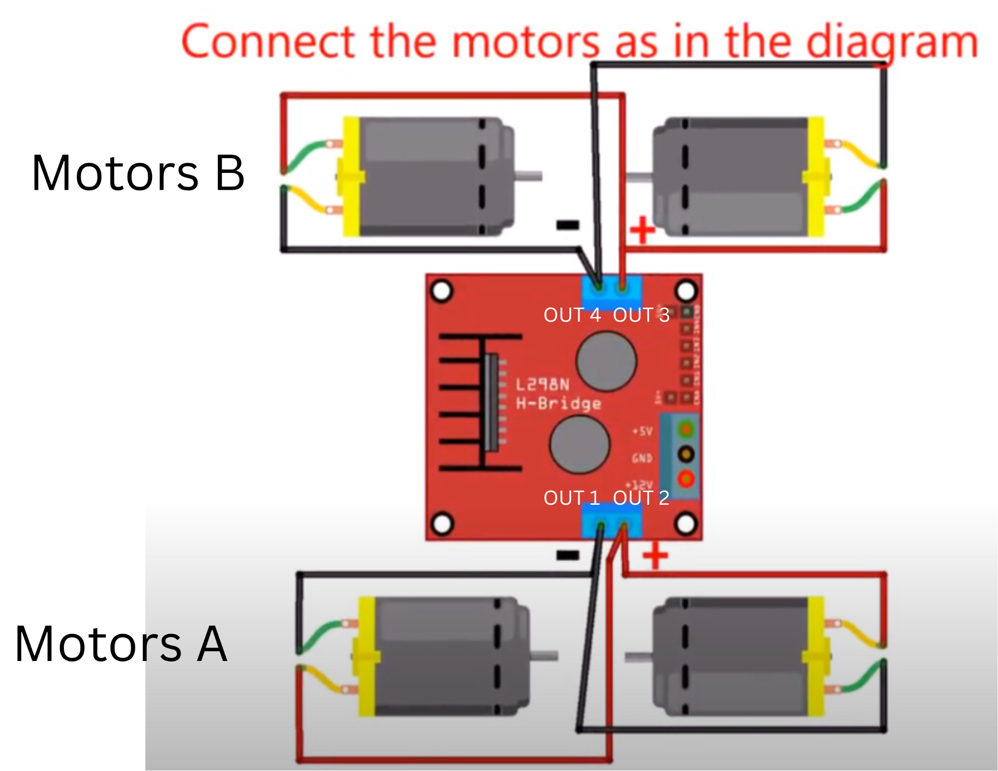

Figure 1.2

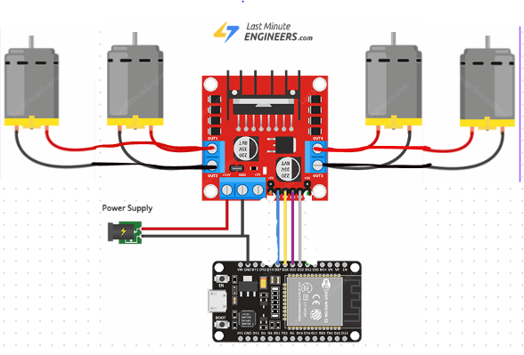

**SYSTEM FLOW DIAGRAM**ESP32 → Motor driver → Motor→ wheels

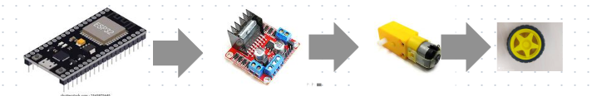

*NOTE: When connecting the wires, the actual slot does not matter as long as positive and negative are in the same place.*

| **Motors A (Left side)** | **Motors B (Right Side)** |
| --- | --- |
| * OUT1 * OUT2 | * OUT3 * OUT4 |

1.3.1 Control Pins (IN1, IN2, IN3, IN4)

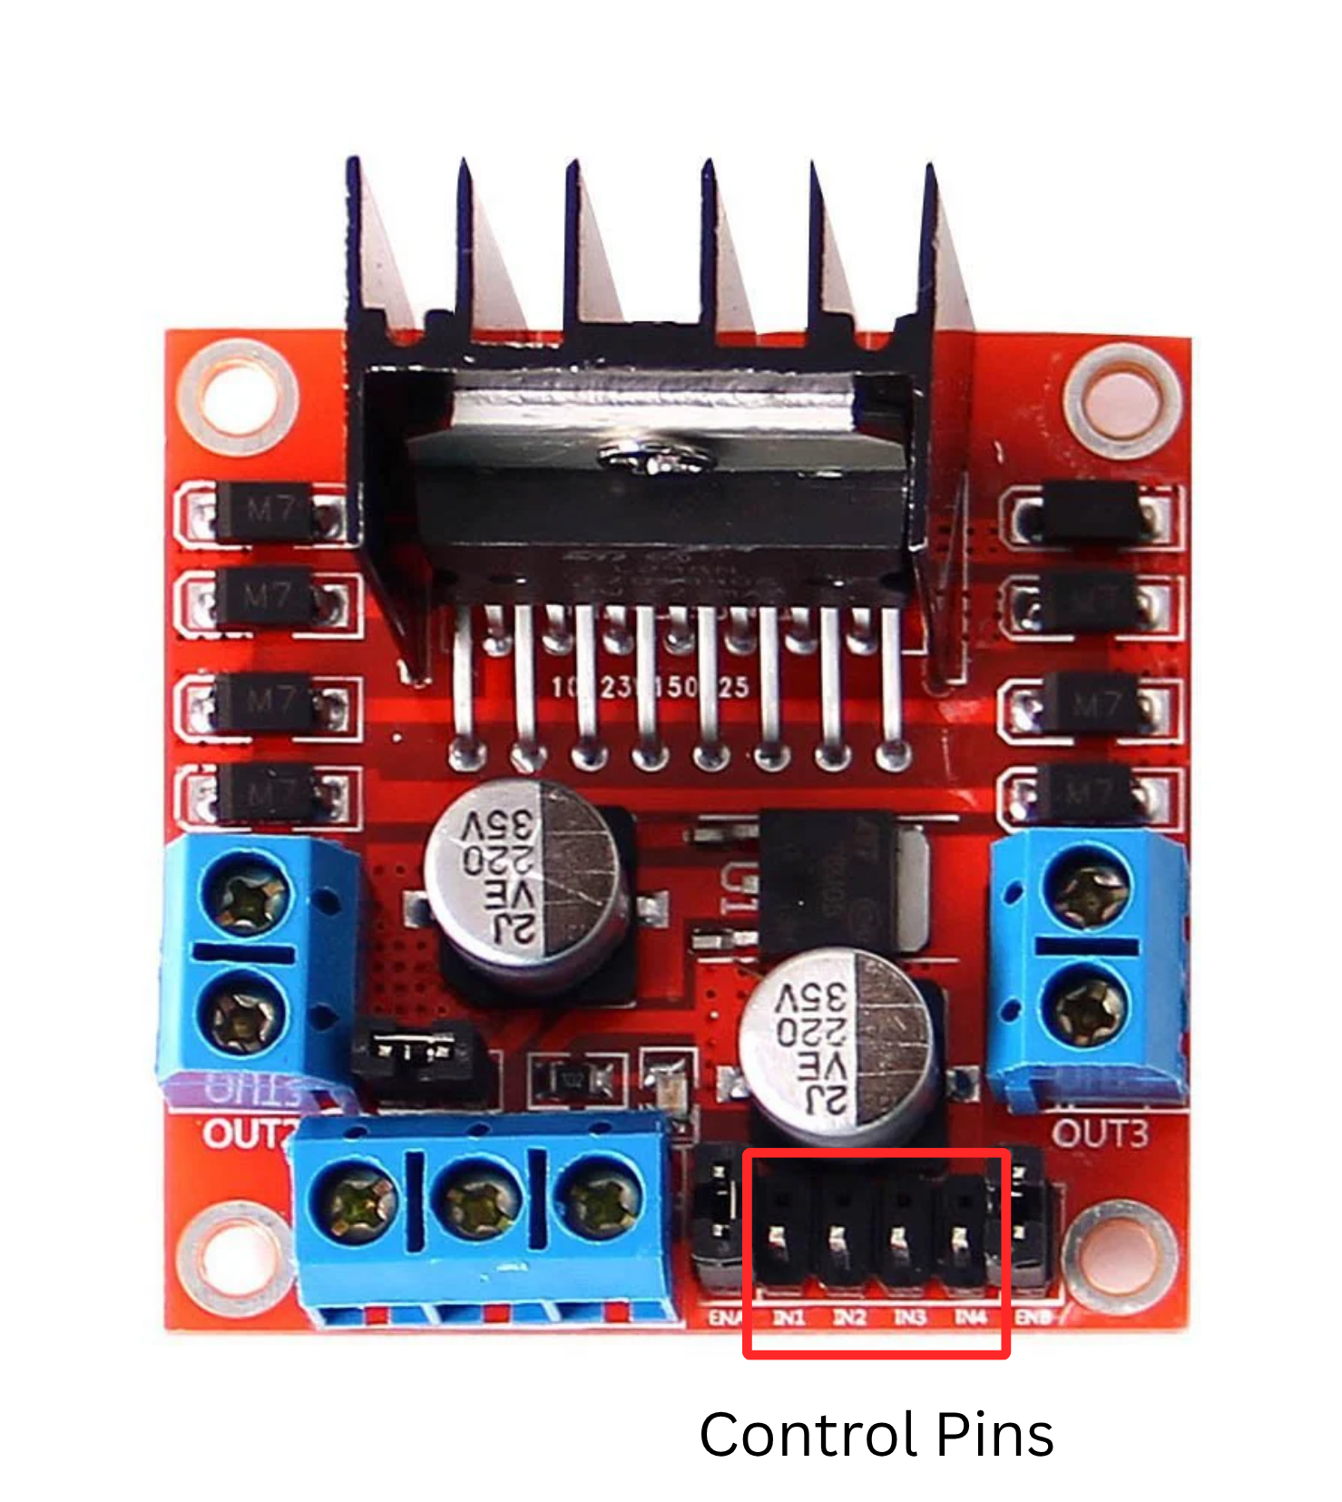

| **IN1, IN2** | **IN3, IN4** |
| --- | --- |
| * Control direction for Motor A * IN1 HIGH + IN2 LOW → forward * IN1 LOW + IN2 HIGH → reverse | * Control direction for Motor B * *(Same Logic)* |

1.3.2 Power Section

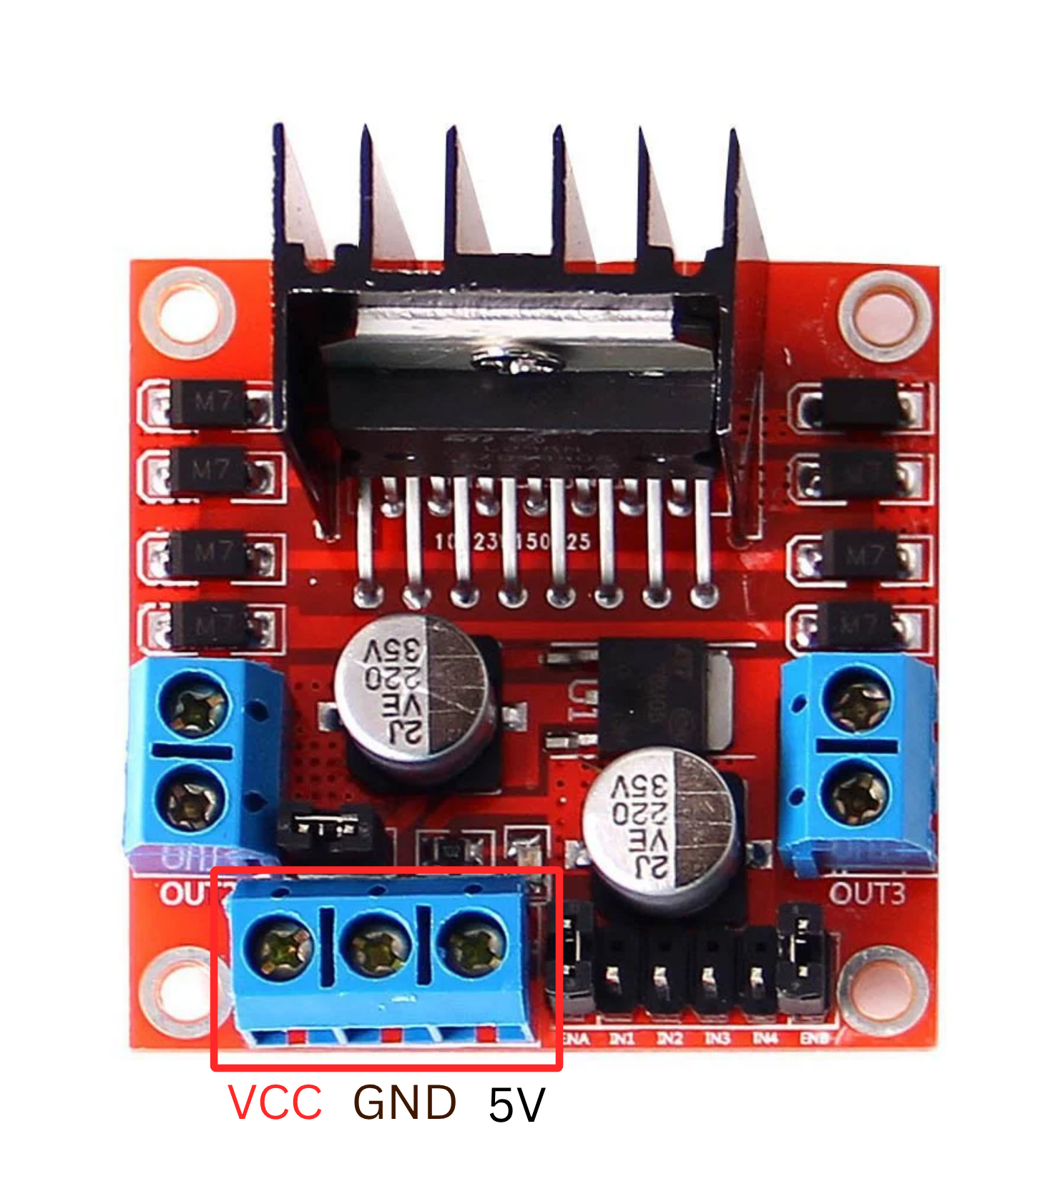

| **VCC** | **GND** | **5V** |
| --- | --- | --- |
| * The main motor power input * Connect to battery | * Battery ground * MUST also connect to ESP32 GND   *\*Common Ground which is connected to ESP32 and Battery is required for signals to make sense.* |  |

1.4 Wiring the Motors (Using Labelled OUT Pins)

**Channel A** → OUT1 & OUT2

Connect both *front motors* in parallel:

· Red wires → OUT1

· Black wires → OUT2

**Channel B** → OUT3 & OUT4

Connect both *rear motors* in parallel:

· Red wires → OUT3

· Black wires → OUT4

Figure 1.4

(Note that there are 4 motors to be connected as shown in Figure 1.2).

*Note: Ignore the Enable pins as we will not be needing them in this workshop.*

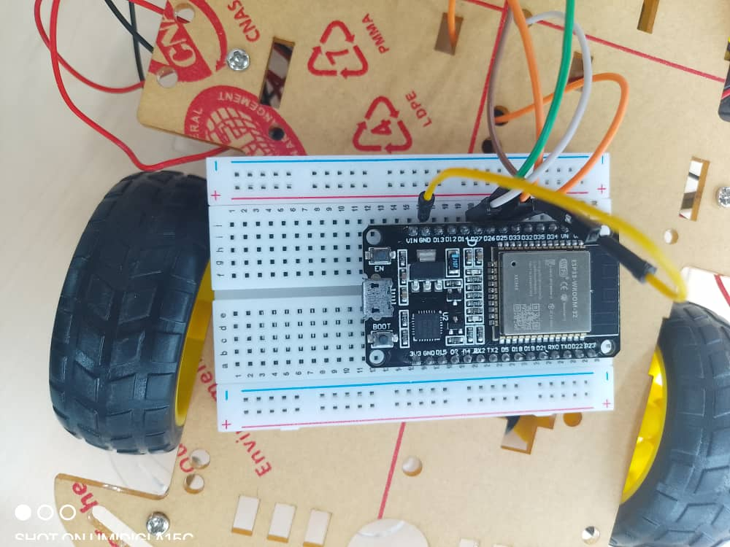

Above is a picture of the ESP32 and the board it is mounted on for better connection. (Still following Figure 1.4)

**Connecting the Motor driver to ESP32 (pins can be changed)**

| **L298N Pin** | **Connect to ESP32** |  |
| --- | --- | --- |
| IN1 | D33 | Motor A direction |
| IN2 | D25 | Motor A direction |
| IN3 | D26 | Motor B direction |
| IN4 | D27 | Motor B direction |
| GND | GND | Common ground |

RECAP, TESTING AND QUESTIONS

ESP32

What is ESP32?

ESP32 is a powerful microcontroller used in robotics, IoT, and automation projects.  
 It comes with:

* Dual-core processor (up to 240 MHz)
* WiFi + Bluetooth
* Multiple GPIO pins
* ADC (Analog inputs)
* PWM pins for motors/servos
* UART, I2C, SPI communication support

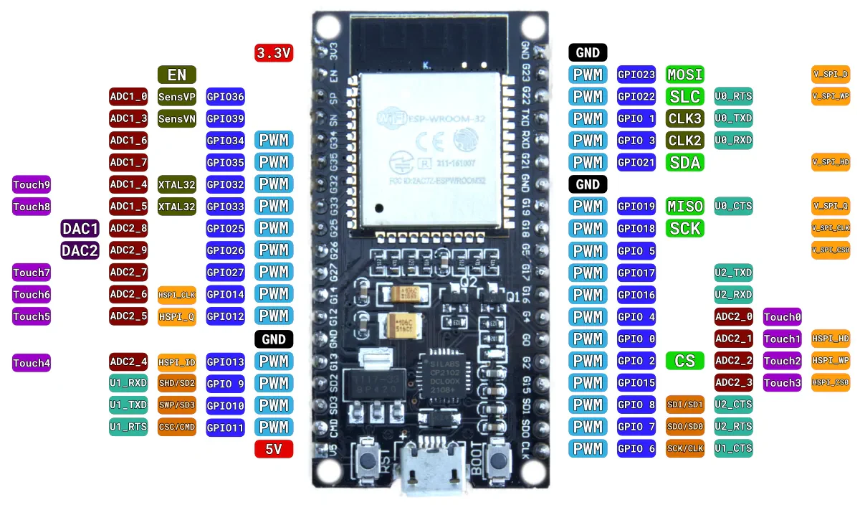

### **Power Pins**

* **3.3V** → Power sensors & logic
* **5V** → Input from USB
* **GND** → Common ground

### **GPIO Pins**

Flexible pins used for digital input/output.

### **ADC Pins (Analog Input)**

* Pins 32, 33, 34, 35, 36, 39

### **PWM Pins (Servo/Motor Signal)**

Almost all GPIOs support PWM  
 Best to use: **GPIO 18, 19, 21, 22, 23, 25, 26, 27**

### **UART Pins (Serial Communication)**

* TX0/RX0 (default)
* Can remap to other GPIOs

# Steps to Install Port Drive:

Check the device manager before downloading the drive. If you find the warning symbol then go for downloading drive, or else Update the drive.

**Step 1:**  Install the file from the provided Link  
**Step 2:**  Open Device Manager

**Step 3:** Double click on the Port

**Step 4:**

## **Steps to Connect ESP32 to Your Laptop**

### **Step 1: Install Arduino IDE**

Latest version recommended.

### **Step 2: Install ESP32 Boards**

**1 2**

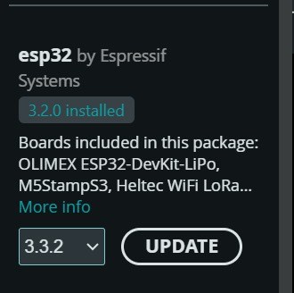

Download this under Board Manager

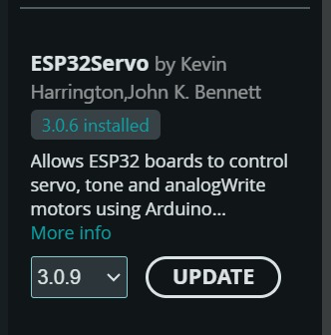

Download under Library

**Step 3: Debugging process for Port Identification**

*Step 1*

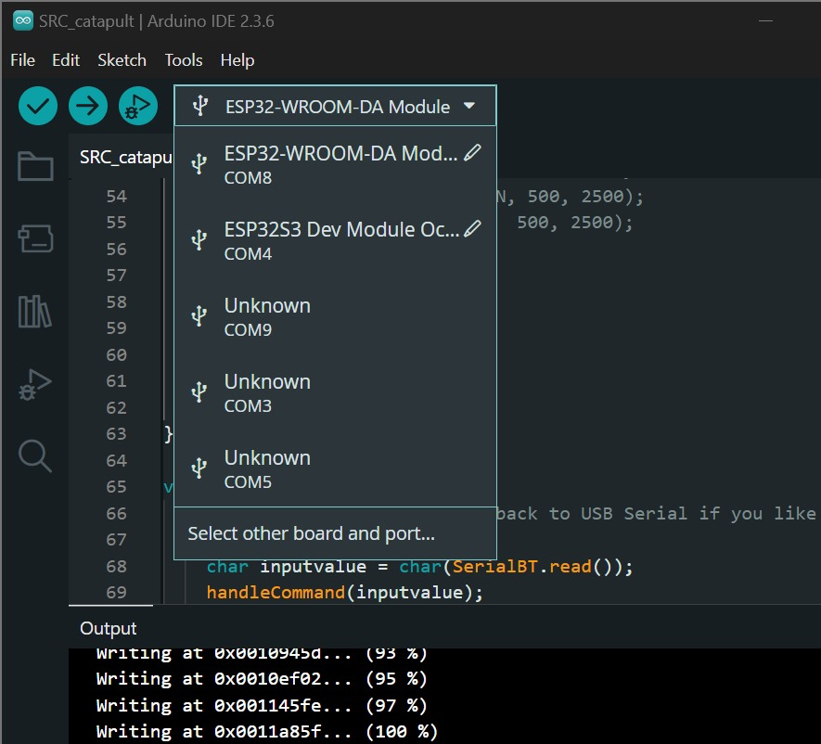

Have your laptop NOT plugged to the ESP32 yet

*Step 2*

Plug in ESP32 and observe the new popped up port

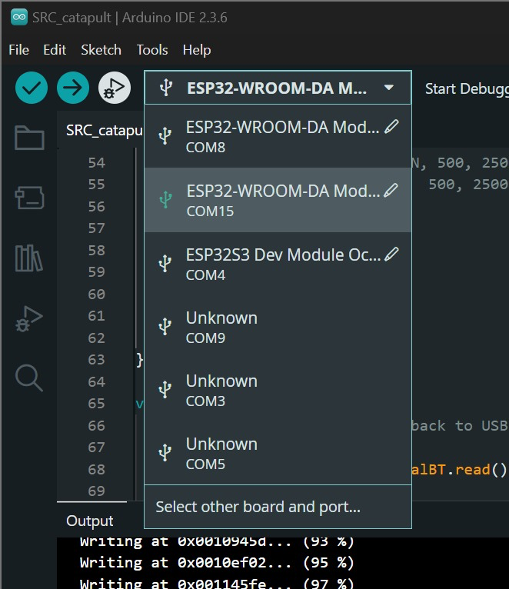

*Step 3*

Select the new port and click "Select other board and port...."

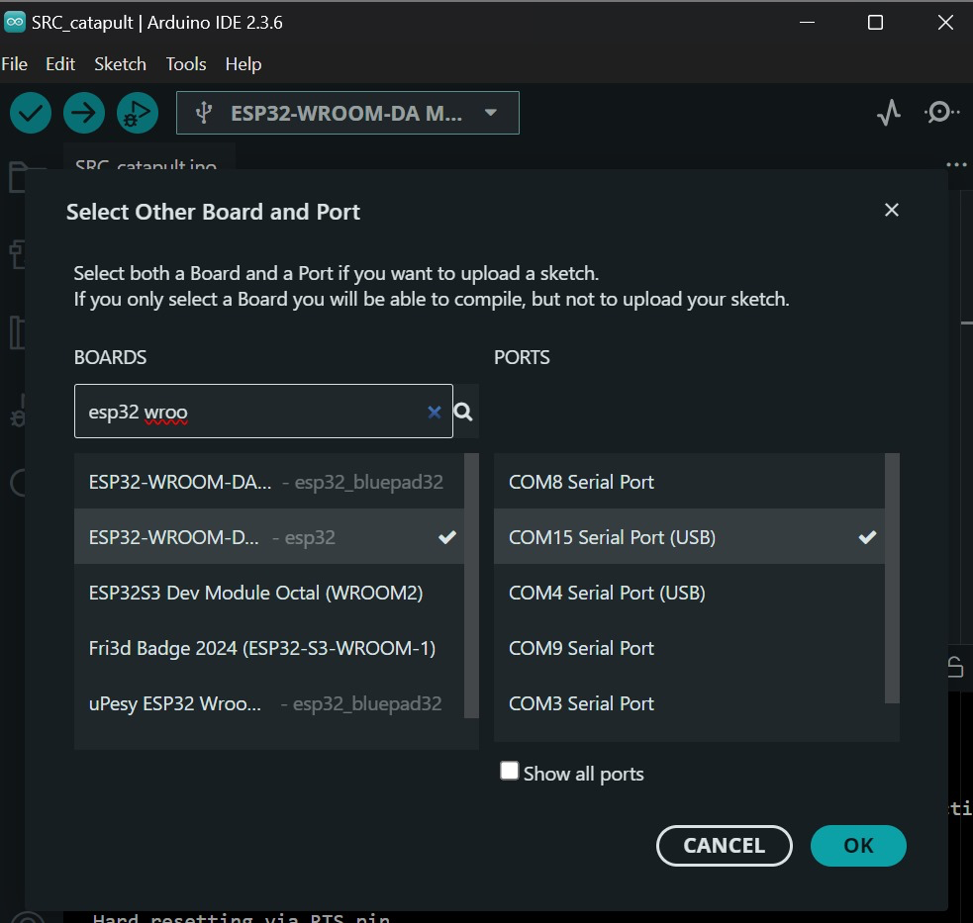

Then select ESP32-WROOM-DA-Module for the board

**Step 4: First Test Program (Blink)**

Paste this in Arduino IDE:

**void setup() {**

**pinMode(2, OUTPUT);**

**}**

**void loop() {**

**digitalWrite(2, HIGH);**

**delay(1000);**

**digitalWrite(2, LOW);**

**delay(1000);**

**}**

Upload → If the LED blinks → ESP32 is working perfectly.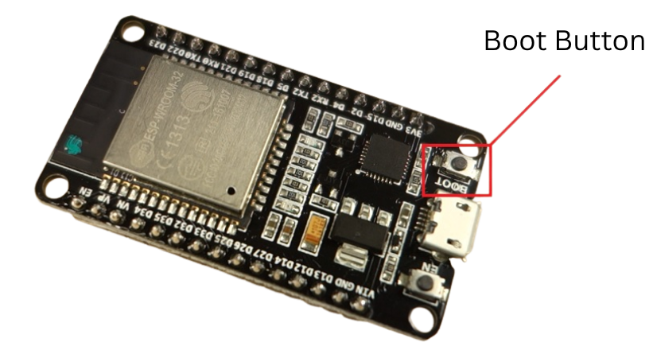

*\*Press BOOT button continuously when you see "Connecting" until it shows the % then could let go.*

**Step 5: Controlling the Robot Car**

#include <BluetoothSerial.h>

BluetoothSerial SerialBT;

#define LED_PIN 2

#define IN1 33

#define IN2 25

#define IN3 26

#define IN4 27

void setup() {

SerialBT.begin("ESP32Bot");

pinMode(LED_PIN, OUTPUT);

digitalWrite(LED_PIN, HIGH);

pinMode(IN1, OUTPUT);

pinMode(IN2, OUTPUT);

pinMode(IN3, OUTPUT);

pinMode(IN4, OUTPUT);

}

void loop() {

if (SerialBT.available()) {

char c = SerialBT.read();

handleCommand(c);

}

}

void handleCommand(char c) {

if (c == 'F') { // Forward

digitalWrite(IN1, HIGH);

digitalWrite(IN2, LOW);

digitalWrite(IN3, HIGH);

digitalWrite(IN4, LOW);

}

else if (c == 'B') { // Backward

digitalWrite(IN1, LOW);

digitalWrite(IN2, HIGH);

digitalWrite(IN3, LOW);

digitalWrite(IN4, HIGH);

}

else if (c == 'L') { // Left

digitalWrite(IN1, HIGH);

digitalWrite(IN2, LOW);

digitalWrite(IN3, LOW);

digitalWrite(IN4, LOW);

}

else if (c == 'R') { // Right

digitalWrite(IN1, LOW);

digitalWrite(IN2, LOW);

digitalWrite(IN3, HIGH);

digitalWrite(IN4, LOW);

}

else if (c == 'A') { // Diagonal

digitalWrite(IN1, HIGH);

digitalWrite(IN2, LOW);

digitalWrite(IN3, LOW);

digitalWrite(IN4, HIGH);

}

else if (c == 'S') { // Stop

digitalWrite(IN1, LOW);

digitalWrite(IN2, LOW);

digitalWrite(IN3, LOW);

digitalWrite(IN4, LOW);

}

}

**Step 6: Bluetooth**

Install Arduino Bluetooth App.

*\*Android only*



**After Opening App:** App Interface 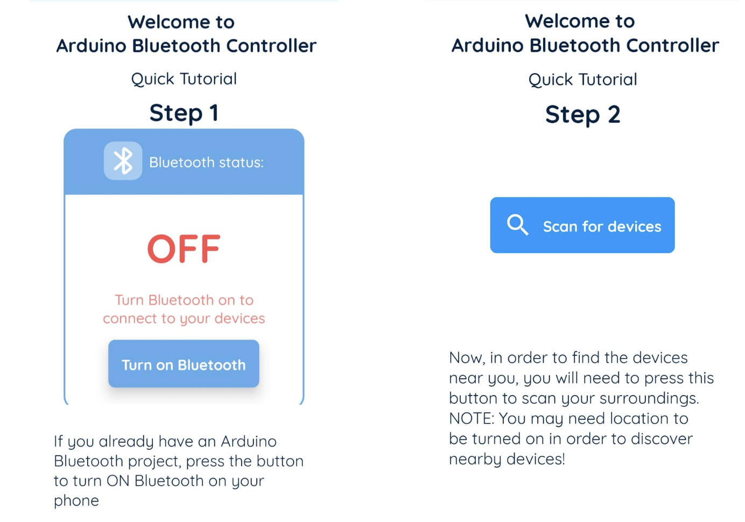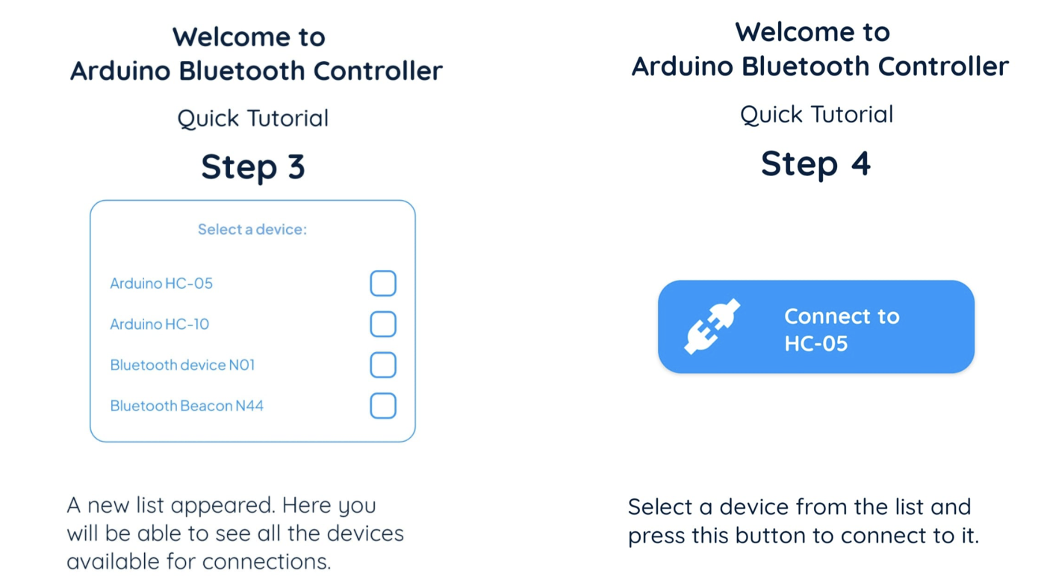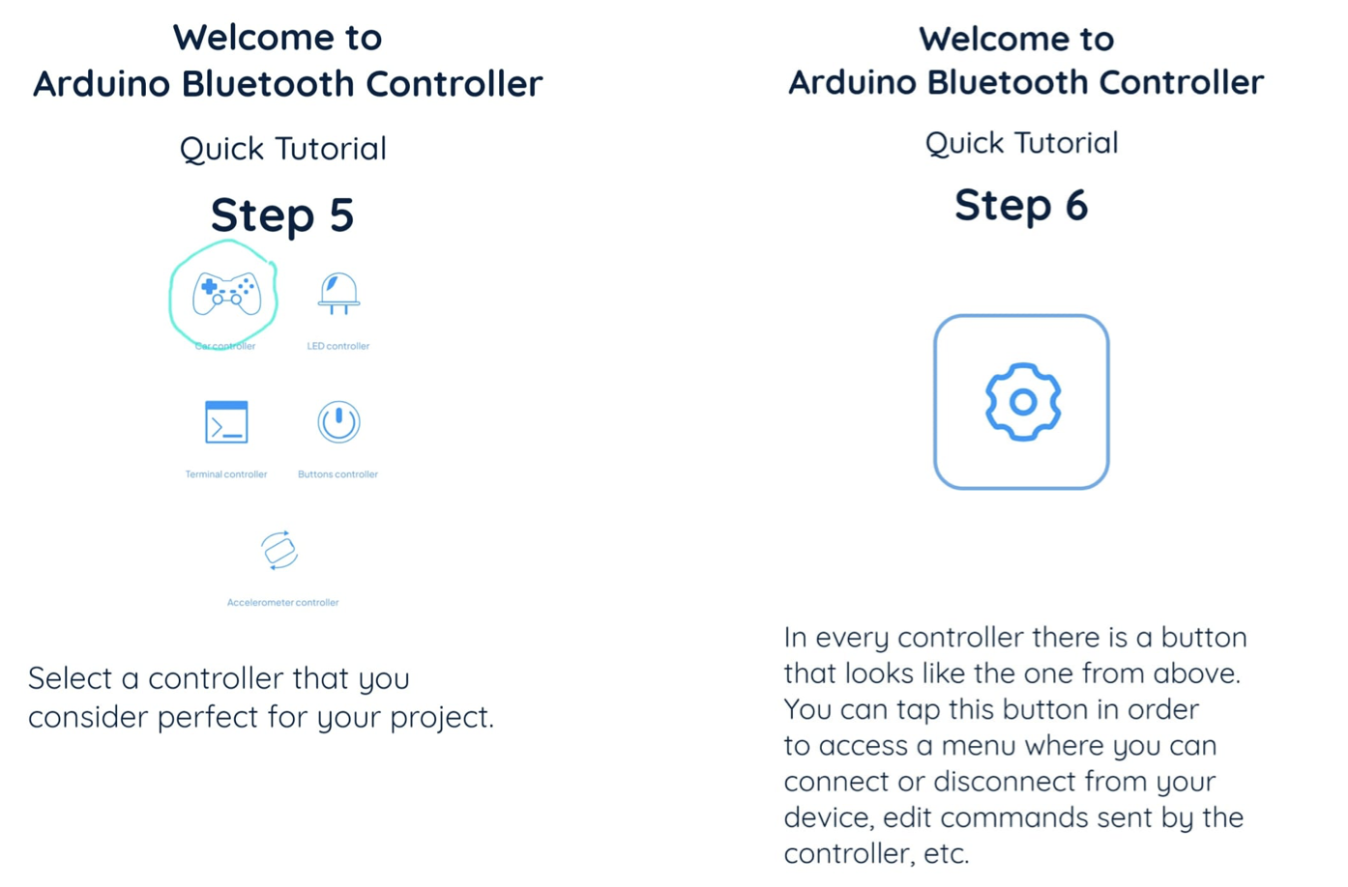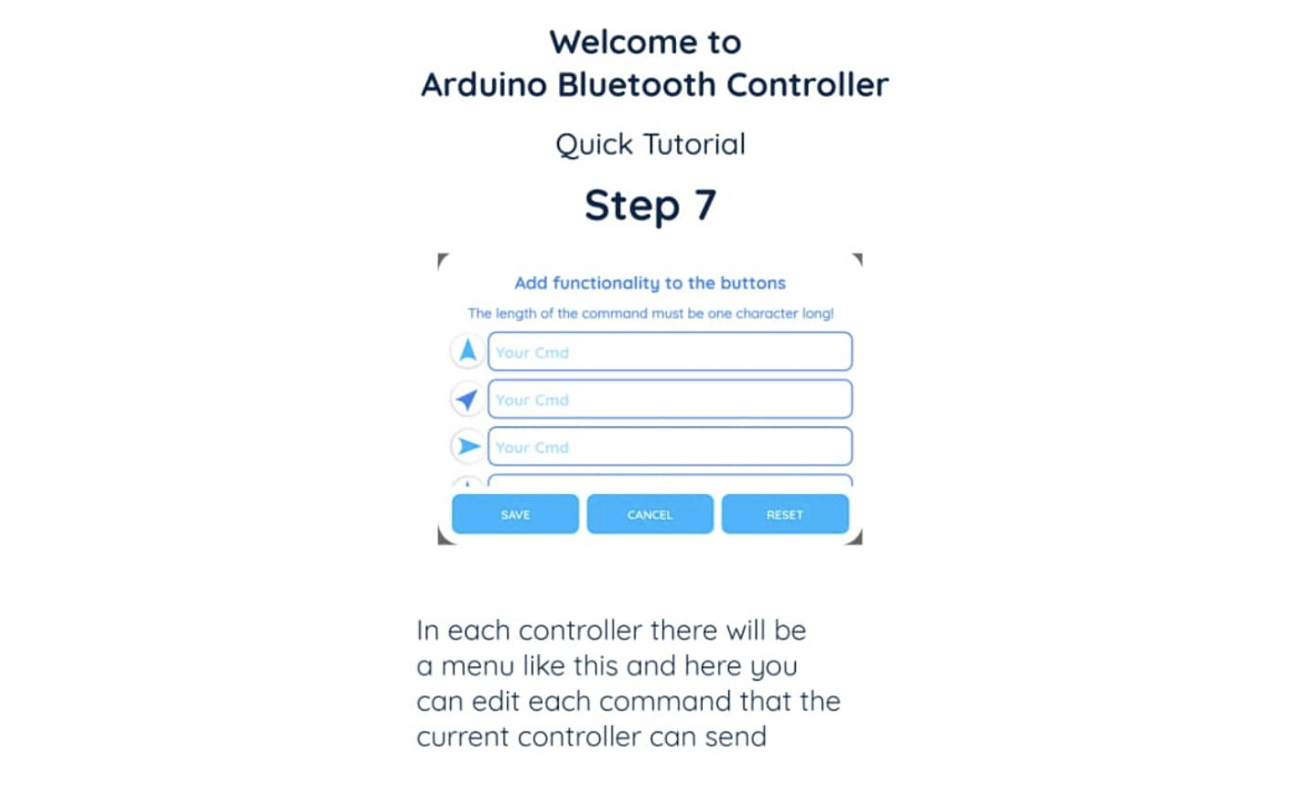

Buck Converter

**5A FIXED USB BUCK CONVERTER**

1. **What Is a Buck Converter?**

A buck converter reduces a higher voltage (ex: battery) to a lower voltage (ex: 5V).

For robotics:

Smooth power

High current

Stable voltage → no random resets

1. **Connection Diagram Input Side**

7V–24V battery or adapter

Positive → VIN

Negative → GND

Output Side (USB Female)

Output is fixed at 5V

Connect USB cable → ESP32

or USB splitter → multiple devices

Servos

# SERVO MOTOR CALIBRATION

### **What is Servo Calibration?**

Calibration ensures:

* Each servo starts at the **correct zero (home) angle**
* Movements are **symmetrical**
* All legs/arms/links start from the same mechanical reference  
   This prevents mechanical binding and burnt gears.

### **Why do we calibrate?**

* So all legs/arms behave identical
* To avoid torque overload
* To ensure accurate walking / rotation / gripping
* To protect expensive servos (especially MG996R, DS3218, etc.)

### **Our Project’s Servo Calibration Steps**

#### **Step 1: Power the Servo Correctly**

* Use the **buck converter → 6V** (or 5V if servo is cheap)
* Never power servos from Arduino 5V pin

#### **Step 2: Upload the Centering Code**

#include <Servo.h>

#define SERVO_PIN 18

const int SERVO_MIN_ANGLE = 0;

const int SERVO_MAX_ANGLE = 180;

const int SERVO_CENTER = 90;

Servo myServo;

int offset = 0;

void moveToAngle(int angle) {

int correctedAngle = angle + offset;

if (correctedAngle < SERVO_MIN_ANGLE) correctedAngle = SERVO_MIN_ANGLE;

if (correctedAngle > SERVO_MAX_ANGLE) correctedAngle = SERVO_MAX_ANGLE;

myServo.write(correctedAngle);

delay(800);

}

void setup() {

Serial.begin(115200);

myServo.attach(SERVO_PIN);

Serial.println("Starting Servo Calibration...");

Serial.println("Centering Servo...");

moveToAngle(SERVO_CENTER);

}

void loop() {

Serial.println("Moving to 0 degrees...");

moveToAngle(0);

Serial.println("Moving to 90 degrees...");

moveToAngle(90);

Serial.println("Moving to 180 degrees...");

moveToAngle(180);

Serial.println("Returning to center...");

moveToAngle(90);

delay(1500);

}

# **1) Required Libraries**

#include <Servo.h>

# **2) Pin Definitions**

#define SERVO_PIN 18

# **3) Angle Conversion Constants**

const int SERVO_MIN_ANGLE = 0;

const int SERVO_MAX_ANGLE = 180;

const int SERVO_CENTER = 90;

# **4) Global Variables**

Servo myServo;

int offset = 0;

# **5) Calibration Helper Function**

void moveToAngle(int angle) {

int correctedAngle = angle + offset;

if (correctedAngle < SERVO_MIN_ANGLE) correctedAngle = SERVO_MIN_ANGLE;

if (correctedAngle > SERVO_MAX_ANGLE) correctedAngle = SERVO_MAX_ANGLE;

myServo.write(correctedAngle);

delay(800);

}

# **6) Setup Function**

void setup() {

Serial.begin(115200);

myServo.attach(SERVO_PIN);

Serial.println("Starting Servo Calibration...");

Serial.println("Centering Servo...");

moveToAngle(SERVO_CENTER);

}

# **7) Loop Function**

void loop() {

moveToAngle(0);

moveToAngle(90);

moveToAngle(180);

moveToAngle(90);

delay(1500);

}